IS/SD EXAM QUESTIONS with PSEUDOCODE errors
Compiled by Mark Kelly

Question 7 – 2006 IS exam
One of the errors that Peter has found is in the code to control the shade curtain motor.
For her flowering orchids, Lucy wants the shade curtain to be closed if the light exceeds 15 000 lux (MaxLight). She also wants the shade curtain closed when the temperature exceeds 33°C (MaxTemp). The curtain should only be opened when the light falls below 7 000 lux (MinLight) and when the temperature drops below 30°C (MinTemp). The light and temperature values will vary depending on the plants grown in each greenhouse ‘room’.

Peter has found that the code follows the algorithm below.

Begin
If Temperature > MaxTemp Or Light >MaxLight Then
CurtainMotor (Close)
Endif
If Temperature < MinTemp Or Light < MinLight Then
CurtainMotor (Open)
Endif
End

a. Below is a testing table. Work out the action that the algorithm finally produces and complete the last column.
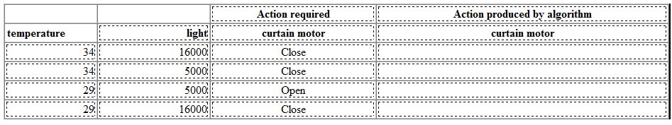
4 marks

b. A line in the algorithm contains a logic error. Identify that line by writing it out in full. 1 mark

c. Describe how this error can be corrected. 1 mark

2007 SD exam Question C3

Kayla has completed her analysis of the system. She has decided to start the design of the new system with the design of the software. From her analysis she knows that one thing the system has to do is to calculate the required amount of each ingredient.
She designs an algorithm that
- reads a file to get the total number of different ingredients Sebastian keeps in stock (Num_Ingredients)
- for each bread item (Product_ID) ordered, uses recipe data and the number of items ordered (Num _ Ord) to
- calculate the amount of each ingredient required for that item (Amount_ Req)
- adds the ingredient amounts required for each item to get the total quantity needed for each ingredient Qty ()

The procedure will have passed to it data that lists the amount of each ingredient required for every bread item made by the bakery (Product_Recipes)

Here is Kayla's algorithm.

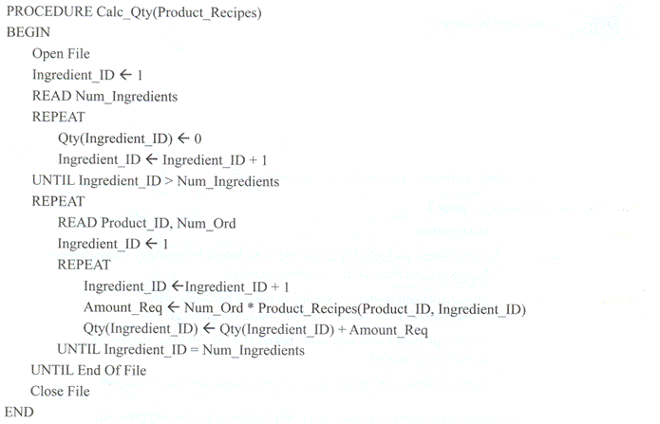

Question 3
a. What is the purpose of the first REPEAT - UNTIL loop? (1 mark)

To test the algorithm Kayla decides to use some simplified test data with only 1 bread product and only 3 ingredients.

b. Using the data below complete the test table (3 marks
Test data
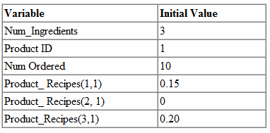
Note: Why is the indexing of the array reversed? It should be (1,3) for example - product 1, ingredient 3. That's the order it is in the algorithm. (Note: this has been confirmed as a rare booboo by the SD exam writers. It's not significant to the answers, however.)

Test table
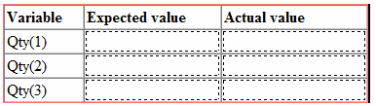
c. Describe the error in this algorithm (1 mark)
d. Suggest one way the algorithm could be altered to fix this error (2 marks)

SD 2008 exam - Question C5
The software specifications show that a procedure is required to enable Pattie to see which event coordinators are available on a particular date. The algorithm for this procedure has been created and is shown below.
The algorithm uses the following variables.
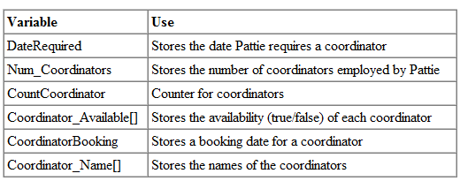
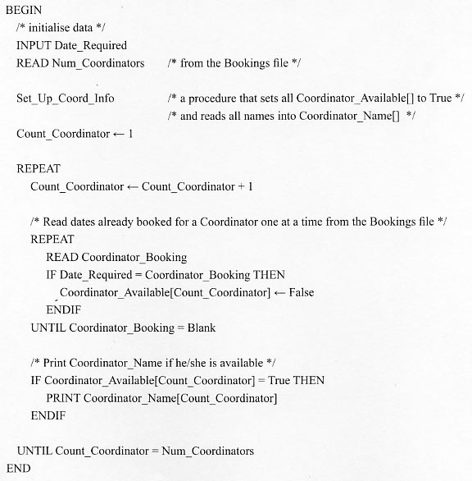

Test data used to check algorithm

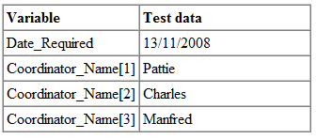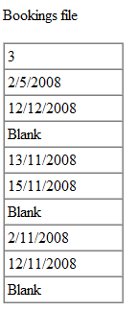

a. Using the test data above

i. What output would you expect to get if the algorithm was correct? 2 marks
ii. What output does the algorithm actually give? 2 marks
b. Describe the error in the algorithm. 2 marks
c. Suggest one way the algorithm could be altered to fix this error.2 marks

Question 6
From the variables used in the algorithm, select one of each type to complete the following table.

Type | Variable Name
Boolean Array
String (Text) Array
Numeric

2009 SD exam QA16
Question 16

Member ID numbers must be between 1 and fifty thousand (50 000). When a new member is added, the program uses the following code to generate a new member ID number.

Member ID = 1 + int(rand( )* 100000/2)

where rand( ) returns a six-digit random number between zero and one, and

int( ) returns the integer part of whatever number is in the brackets.

If a new member is being added and rand( ) returns 0.002222 then Member ID will be set to

A. 2
B. 12
C. 112
D. 1112

Question C7

During her analysis of the system, Rose interviewed all the assemblers in the Melbourne factory. One assembler mentioned that sometimes RoboCut would reject a good piece of timber.
Rose investigates this and finds that the problem started after the last software upgrade six months ago. She contacts MyCut and it claims that none of its other users have reported this problem. After some argument MyCut agrees to send Rose the algorithms related to the software changes. She finds one algorithm that has to do with the cutting process. RoboCut uses this algorithm to check whether or not a piece of timber is long enough to use.

Function Check_Length(Timber_Length, LengthRequired)
Begin
If Timber_Length > Length_Required Then
Return true
Else
Return false
End if
End

Rose decides to test this algorithm by choosing a length of timber (Timber_Length) of 2.4 metres. For the other variable (Length_Required) she chooses the values 2.3, 2.4 and 2.5.

a. Explain why Rose selected these values. 3 marks

b. Complete the following table showing what the algorithm should return and what it actually returns. (2)
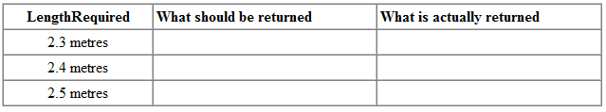

c. Explain why RoboCut only sometimes rejects a good piece of timber. (1)
d. State one alteration to the algorithm that would correct this error. (1)

SD Exam 2010 section A
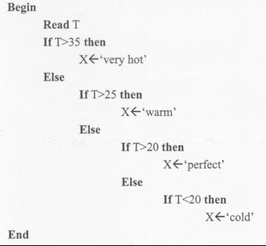

Question 6
When the above algorithm was tested it was found that it did not provide the correct result when T=20. This was caused by a
A. logic error.
B. syntax error.
C. run time error.
D. compile time error.

Question 7
Test the above algorithm with the value T=25. The variable X will contain
A. 'cold'
B. 'warm'
C. 'perfect'
D. 'very hot'

Question C9

During the trial it was found that when nurses changed their passwords for the portable devices the program failed and they were locked out. Investigation found that entering certain characters caused the problem, so it was decided to limit the passwords to just alphabetic letters and numbers. Suzie has suggested the algorithm below to validate a new password before it is stored in the system. She must now test it.
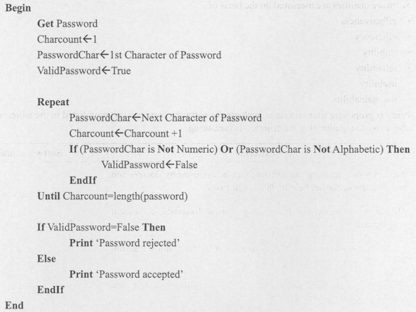

Suzie created the test data shown below.
a. For each item of data, give a reason for why that data was chosen.

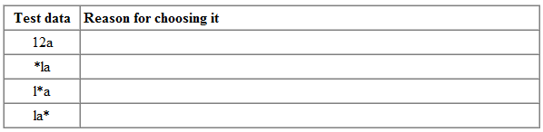
b. Suggest one other item of data that will test another aspect of the password procedure and explain why it should also be used.

Question 10
a. For the algorithm in Question 9, complete the test table below showing what output is expected from the test data and what it actually produces. (2)
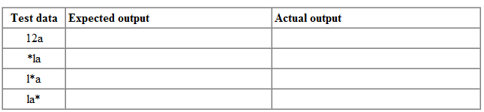

Suzie found her algorithm does not produce the output expected.
b. Explain why the algorithm is giving the wrong output. (2)
c. Explain how the algorithm could be corrected. (3)

